LINUX ASSIGNMENT
1. Creating and Renaming Files/Directories
- Commands:
  - mkdir test_dir
  - cd test_dir
  - touch example.txt
  - mv example.txt renamed_example.txt
- Explanation:
  - Created a directory, created an empty file inside it, and renamed the file.

2. Viewing File Contents
- Commands:
  - cat /etc/passwd
  - head -5 /etc/passwd
  - tail -5 /etc/passwd
- Explanation:
  - Displayed the whole file, first 5 lines, and last 5 lines.

3. Searching for Patterns
- Command:
  - grep "root" /etc/passwd
- Explanation:
  - Searched and displayed all lines containing the word "root".

4. Zipping and Unzipping
- Commands:
  - sudo apt install zip unzip
  - zip -r test_dir.zip test_dir
  - mkdir unzipped_dir
  - unzip test_dir.zip -d unzipped_dir
- Explanation:

5. Downloading Files
- Commands:
  - sudo apt install wget
  - wget https://www.w3.org/TR/PNG/iso_8859-1.txt
- Explanation:
  - Installed wget and downloaded a sample text file.

6. Changing Permissions
- Commands:
  - touch secure.txt
  - chmod 444 secure.txt
  - ls -l secure.txt
- Explanation:
  - Created a file and changed permissions to read-only for everyone.

7. Working with Environment Variables
- Commands:
  - export MY_VAR="Hello, Linux!"
  - echo $MY_VAR
- Explanation:
  - Created a new environment variable and displayed its value.
OUTPUT
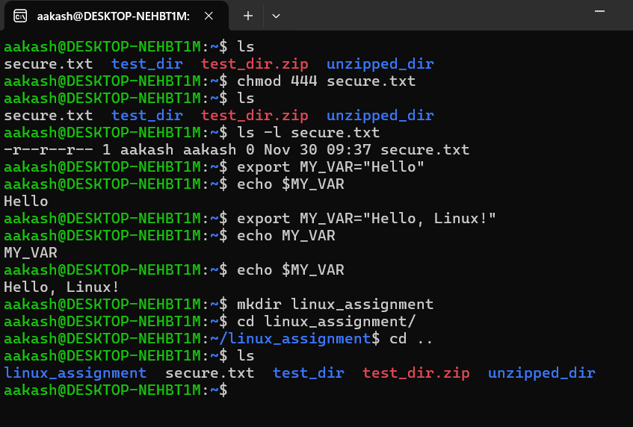
GITHUB REPO LINK
https://github.com/aakash-ka-project/linux_assignment

